exported all the logs of firewall rules by creating a sink

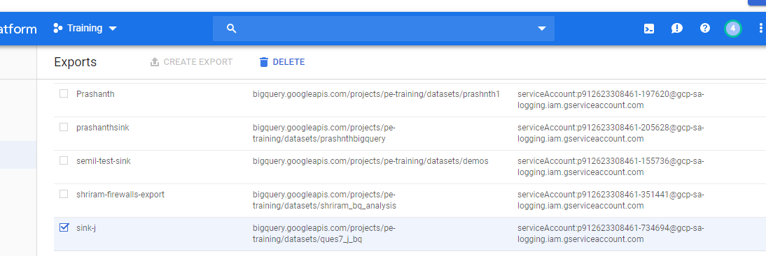

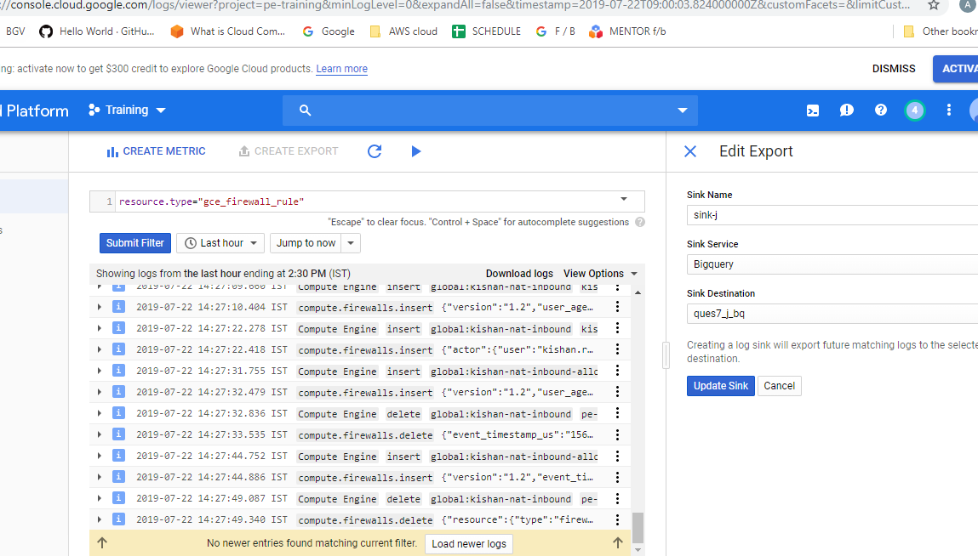

Bigquery: ques7_j_bq

Dataset and tables are created but there is a problem in exporting logs.

